For (1) and (2) below, you’re choosing between two candidates to hire. Discuss the pros and cons of choosing one candidate over the other in the following situations.

1. Both are predicted to have the same productivity score of 75, but have the following probabilistic forecasts.

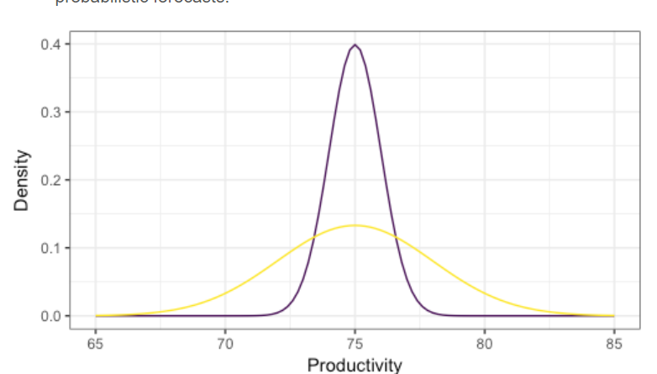

A: More reliable to be close to the expected productivity. Cannot expect to me more flexible when there is higher productivity expected

B: Less reliable to be close to the expected productivity. However, can be more useful than in those cases when higher productivity than usual is expected.

1. Two “non-overlapping” forecasts:

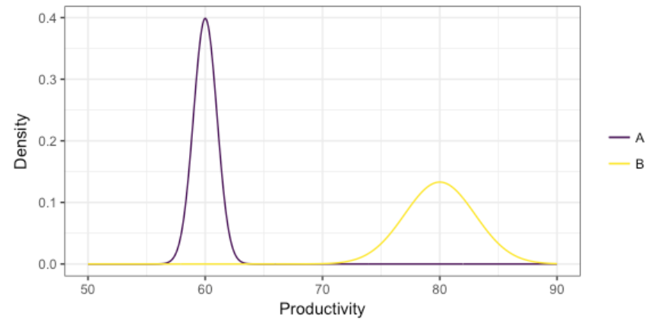

B: B is better in this case as it shows a higher productivity. However, a person with higher average productivity would probably expect a higher salary. On that scale the disadvantage of B would be that B would be less reliable.

A: More reliable but has lesser average productivity.

1. You’ve formed a probabilist forecast for a particular value of the predictors, displayed below as a density. You then collect test data for that same value of the predictor, indicated as the points below the density. What is the problem with the probabilistic forecast?

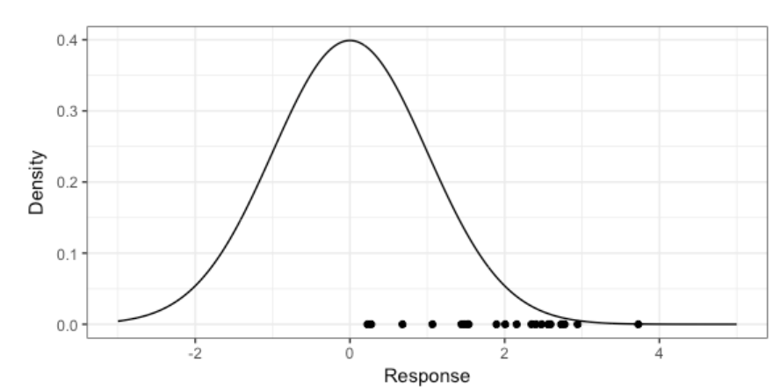

This case might be the case where the probabilistic forecast might not be calibrated. To calibrate, we might have to increase the value of the mean. That would have given a better result.

We might want to collect some more data and check for the actual distribution.